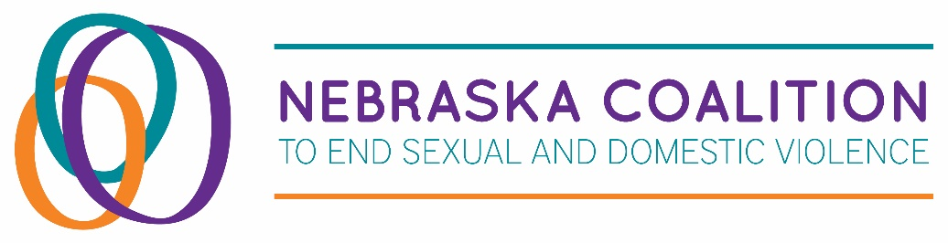

Infusion Fund
An empowerment program for adult survivors of domestic violence,
sexual assault, and human trafficking

Name of Agency: Click here to enter text.
(requesting on behalf of survivor)

Agency Contact Person: Click here to enter text.
Contact Person’s Email: Click here to enter text.
Contact Person’s Phone Number: Click here to enter text.
Survivor Assistance Requested: Click here to enter text.
Amount of Money Requested: Click here to enter text.
Make Check Payable to: Click here to enter text.
(It is preferred that the check be payable to the referring agency when at all possible.
If this is not possible, the check may be made payable to the business providing service.)

Memo Information for Check: Click here to enter text.
(Apartment, account, or tracking number etc. Do not share the survivors name.)

Send Check to: Click here to enter text.
(Mailing address including the name of the organization or business)

Today’s Date: Click here to enter a date.
Date the support is needed: Click here to enter a date.

Please share any other information that may be relevant to this application.
Click here to enter text.

Approximate age of survivor:

☐18-24
☐25-59
☐60+

Race of survivor:

☐American Indian/Alaska Native
☐Asian
☐Black or African American
☐Hispanic or Latino
☐Native Hawaiian/Other Pacific Islander
☐White
☐Unknown/Other

Gender of survivor:

☐Female
☐Male
☐Transgender
☐Non-binary/Non-conforming
☐Other
☐Prefer not to respond

Please email completed applications with the subject line “Infusion Fund” to:
infusionfund@nebraskacoalition.org

